Overview of the Relationship Management Menu in ESXp
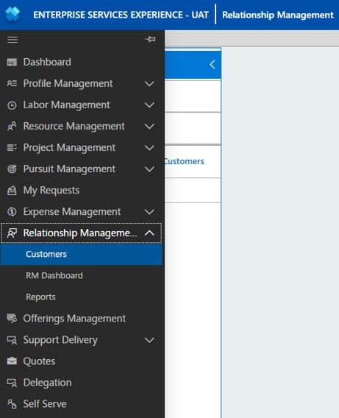
The RMEx menu offers the following selection options:

Customers
This is where your customer account information lives. You can check package entitlements or consumption, log Support Needs and draft Support Projects, and dispatch Deliveries from this section.

RM Dashboard
Here you can view dashboard metrics for Total Agreements Due for Renewal, Key Actions, Utilization, Reactive Cases, Proactive and Reactive Deliveries, CPE Surveys, and Cloud Matches.

Reports
View the Planning and Delivery Details reports for each Customer. You can see Agreement Active and Future Packages, as well as Deliveries in the Current, Future, and Past Agreement Periods.
CSAM-Ms have an aggregate view including metrics for all CSAMs reporting to them.
RMEx organizes and schedules proactive services delivery activities using Customers as unique containers for each account. Through Customer Planning, Relationship Managers deliver services to achieve customer goals and realize support project value for each customer. Deliveries will be displayed for all the accounts where the user is either the owner of the customer plan or a team member assigned to the customer plan (added to the Microsoft Contacts section at the Package level.)
In previous versions of RMEx, the container for all deliveries was the SDP, or Service Delivery Plan. This container has been replaced with one that maps to the overall customer. The Customer persists indefinitely. Each annual agreement can include several packages, formerly called schedules. All delivery history will remain in this construct in RMEx, despite time-bound agreements (or contracts.) If you are a new CSAM or freshly assigned to an account, you will be able to see all delivery history for a Customer once you link their current package(s) to the Customer in RMEx. Select All Customers to view historical data.

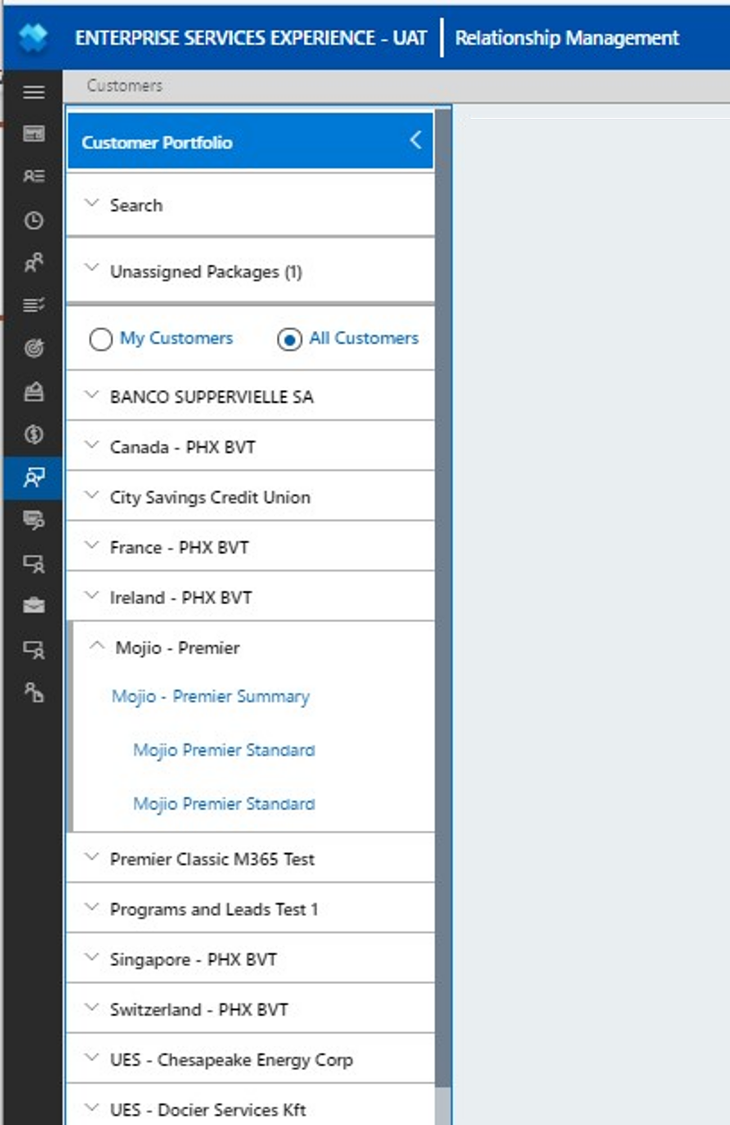
From the Customer Portfolio menu, select My Customers or All Customers.
My Customers will show all Customers of which you are listed as the Owner.
All Customers will show all Customers for which you have been assigned a role and includes a list of expired agreements.

Expand each Customer name to see the Customer Summary, which is always the first link, and each Customer Package(s) linked underneath the Summary.
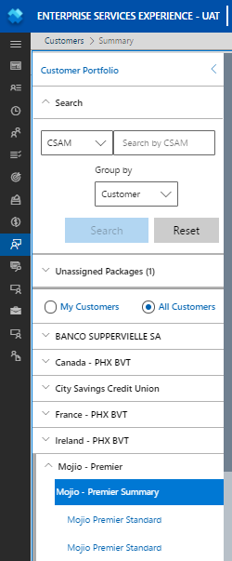
Customer Portfolio with Search feature showing/ expanded; you can search by CSAM or Agreement number.

Customer
Customer Summary (previously known as SDP)

Packages

Overview of the Relationship Management Menu in ESXp
The RMEx menu offers the following selection options:

Customers
This is where your customer account information lives. You can check package entitlements or consumption, log Support Needs and draft Support Projects, and dispatch Deliveries from this section.

RM Dashboard
Here you can view dashboard metrics for Total Agreements Due for Renewal, Key Actions, Utilization, Reactive Cases, Proactive and Reactive Deliveries, CPE Surveys, and Cloud Matches.

Reports
View the Planning and Delivery Details reports for each Customer. You can see Agreement Active and Future Packages, as well as Deliveries in the Current, Future, and Past Agreement Periods.
CSAM-Ms have an aggregate view including metrics for all CSAMs reporting to them.
RMEx organizes and schedules proactive services delivery activities using Customers as unique containers for each account. Through Customer Planning, Relationship Managers deliver services to achieve customer goals and realize support project value for each customer. Deliveries will be displayed for all the accounts where the user is either the owner of the customer plan or a team member assigned to the customer plan (added to the Microsoft Contacts section at the Package level.)
In previous versions of RMEx, the container for all deliveries was the SDP, or Service Delivery Plan. This container has been replaced with one that maps to the overall customer. The Customer persists indefinitely. Each annual agreement can include several packages, formerly called schedules. All delivery history will remain in this construct in RMEx, despite time-bound agreements (or contracts.) If you are a new CSAM or freshly assigned to an account, you will be able to see all delivery history for a Customer once you link their current package(s) to the Customer in RMEx. Select All Customers to view historical data.

From the Customer Portfolio menu, select My Customers or All Customers.
My Customers will show all Customers of which you are listed as the Owner.
All Customers will show all Customers for which you have been assigned a role and includes a list of expired agreements.

Expand each Customer name to see the Customer Summary, which is always the first link, and each Customer Package(s) linked underneath the Summary.
Customer Portfolio with Search feature showing/ expanded; you can search by CSAM or Agreement number.

Customer
Customer Summary (previously known as SDP)

Packages

Overview of the Relationship Management Menu in ESXp
The RMEx menu offers the following selection options:

Customers
This is where your customer account information lives. You can check package entitlements or consumption, log Support Needs and draft Support Projects, and dispatch Deliveries from this section.

RM Dashboard
Here you can view dashboard metrics for Total Agreements Due for Renewal, Key Actions, Utilization, Reactive Cases, Proactive and Reactive Deliveries, CPE Surveys, and Cloud Matches.

Reports
View the Planning and Delivery Details reports for each Customer. You can see Agreement Active and Future Packages, as well as Deliveries in the Current, Future, and Past Agreement Periods.
CSAM-Ms have an aggregate view including metrics for all CSAMs reporting to them.
RMEx organizes and schedules proactive services delivery activities using Customers as unique containers for each account. Through Customer Planning, Relationship Managers deliver services to achieve customer goals and realize support project value for each customer. Deliveries will be displayed for all the accounts where the user is either the owner of the customer plan or a team member assigned to the customer plan (added to the Microsoft Contacts section at the Package level.)
In previous versions of RMEx, the container for all deliveries was the SDP, or Service Delivery Plan. This container has been replaced with one that maps to the overall customer. The Customer persists indefinitely. Each annual agreement can include several packages, formerly called schedules. All delivery history will remain in this construct in RMEx, despite time-bound agreements (or contracts.) If you are a new CSAM or freshly assigned to an account, you will be able to see all delivery history for a Customer once you link their current package(s) to the Customer in RMEx. Select All Customers to view historical data.

From the Customer Portfolio menu, select My Customers or All Customers.
My Customers will show all Customers of which you are listed as the Owner.
All Customers will show all Customers for which you have been assigned a role and includes a list of expired agreements.

Expand each Customer name to see the Customer Summary, which is always the first link, and each Customer Package(s) linked underneath the Summary.
Customer Portfolio with Search feature showing/ expanded; you can search by CSAM or Agreement number.

Customer
Customer Summary (previously known as SDP)

Packages

Overview of the Relationship Management Menu in ESXp
The RMEx menu offers the following selection options:

Customers
This is where your customer account information lives. You can check package entitlements or consumption, log Support Needs and draft Support Projects, and dispatch Deliveries from this section.

RM Dashboard
Here you can view dashboard metrics for Total Agreements Due for Renewal, Key Actions, Utilization, Reactive Cases, Proactive and Reactive Deliveries, CPE Surveys, and Cloud Matches.

Reports
View the Planning and Delivery Details reports for each Customer. You can see Agreement Active and Future Packages, as well as Deliveries in the Current, Future, and Past Agreement Periods.
CSAM-Ms have an aggregate view including metrics for all CSAMs reporting to them.
RMEx organizes and schedules proactive services delivery activities using Customers as unique containers for each account. Through Customer Planning, Relationship Managers deliver services to achieve customer goals and realize support project value for each customer. Deliveries will be displayed for all the accounts where the user is either the owner of the customer plan or a team member assigned to the customer plan (added to the Microsoft Contacts section at the Package level.)
In previous versions of RMEx, the container for all deliveries was the SDP, or Service Delivery Plan. This container has been replaced with one that maps to the overall customer. The Customer persists indefinitely. Each annual agreement can include several packages, formerly called schedules. All delivery history will remain in this construct in RMEx, despite time-bound agreements (or contracts.) If you are a new CSAM or freshly assigned to an account, you will be able to see all delivery history for a Customer once you link their current package(s) to the Customer in RMEx. Select All Customers to view historical data.

From the Customer Portfolio menu, select My Customers or All Customers.
My Customers will show all Customers of which you are listed as the Owner.
All Customers will show all Customers for which you have been assigned a role and includes a list of expired agreements.

Expand each Customer name to see the Customer Summary, which is always the first link, and each Customer Package(s) linked underneath the Summary.
Customer Portfolio with Search feature showing/ expanded; you can search by CSAM or Agreement number.

Customer
Customer Summary (previously known as SDP)

Packages

Overview of the Relationship Management Menu in ESXp
The RMEx menu offers the following selection options:

Customers
This is where your customer account information lives. You can check package entitlements or consumption, log Support Needs and draft Support Projects, and dispatch Deliveries from this section.

RM Dashboard
Here you can view dashboard metrics for Total Agreements Due for Renewal, Key Actions, Utilization, Reactive Cases, Proactive and Reactive Deliveries, CPE Surveys, and Cloud Matches.

Reports
View the Planning and Delivery Details reports for each Customer. You can see Agreement Active and Future Packages, as well as Deliveries in the Current, Future, and Past Agreement Periods.
CSAM-Ms have an aggregate view including metrics for all CSAMs reporting to them.
RMEx organizes and schedules proactive services delivery activities using Customers as unique containers for each account. Through Customer Planning, Relationship Managers deliver services to achieve customer goals and realize support project value for each customer. Deliveries will be displayed for all the accounts where the user is either the owner of the customer plan or a team member assigned to the customer plan (added to the Microsoft Contacts section at the Package level.)
In previous versions of RMEx, the container for all deliveries was the SDP, or Service Delivery Plan. This container has been replaced with one that maps to the overall customer. The Customer persists indefinitely. Each annual agreement can include several packages, formerly called schedules. All delivery history will remain in this construct in RMEx, despite time-bound agreements (or contracts.) If you are a new CSAM or freshly assigned to an account, you will be able to see all delivery history for a Customer once you link their current package(s) to the Customer in RMEx. Select All Customers to view historical data.

From the Customer Portfolio menu, select My Customers or All Customers.
My Customers will show all Customers of which you are listed as the Owner.
All Customers will show all Customers for which you have been assigned a role and includes a list of expired agreements.

Expand each Customer name to see the Customer Summary, which is always the first link, and each Customer Package(s) linked underneath the Summary.
Customer Portfolio with Search feature showing/ expanded; you can search by CSAM or Agreement number.

Customer
Customer Summary (previously known as SDP)

Packages

